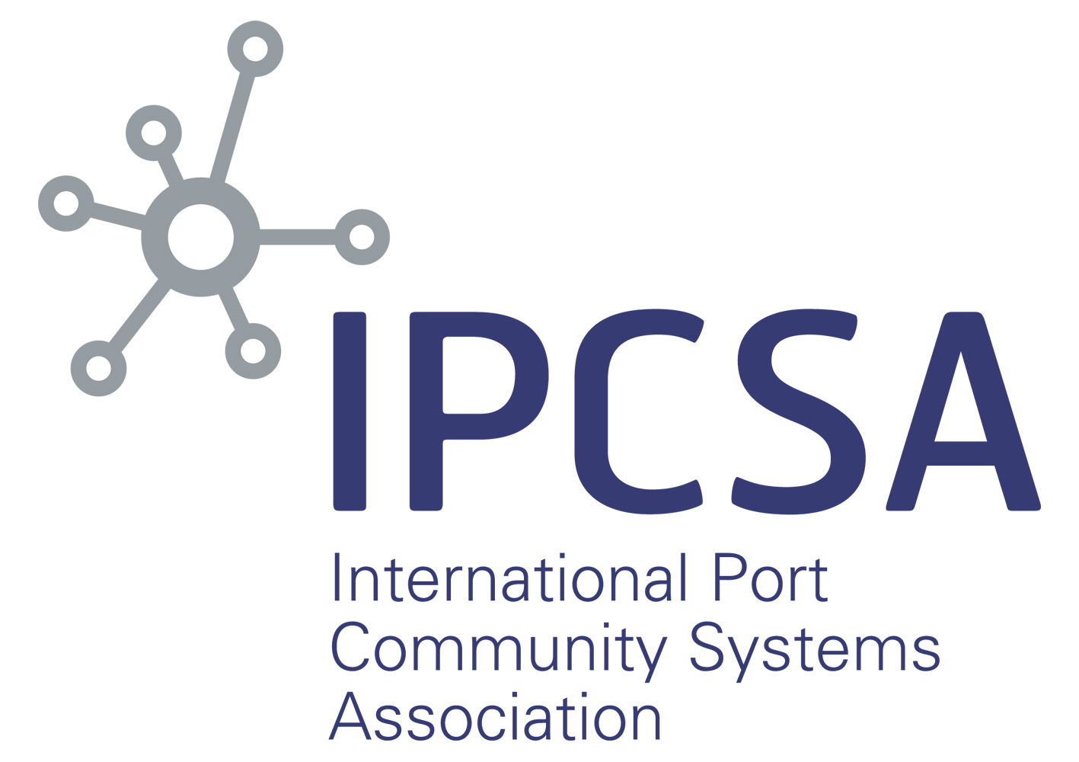

International Port Community Systems Association

Membership Application Form 2020

Membership

Membership to IPCSA is open to:

• Air and Sea Port Community System Operators
• Air and Sea Port Authorities
• Single Window Operators
• International and Regional Organisations and Associations

Member Fee level 2020 (1st January 2020 to 31st December 2020)

The Membership fee for 2020 is €6,000 (plus VAT where applicable).

All membership fees are payable in full within 30 days of membership fee invoice and membership commences from payment date. Membership fee levels for subsequent years is subject to change. IPCSA is a UK VAT registered company.

IPCSA Initiatives

IPCSA develops initiatives to support IPCSA members which are all voluntary, some of these initiatives may have additional fees and costs to help set up, deliver and promote them, which would be clearly set out in advance. It is the choice of members to be involved in such initiatives and pay any additional fees for direct involvement.

Note: For initiatives there may be additional costs over the membership fee and these will be advised to all members who then choose whether to participate or not.

Definitions

A Port Community System Operator:

- is an organisation that is either public, private or public/private that operates and maintains a Port Community System and where the Port Community System represents the core of that organisations business.
- has a board, or some form of steering committee, made up of representatives from different internal and external groups within the Port and Logistics community
- has “service level agreements” with PCS users to manage the electronic exchange of information between different parties on their behalf.

A Single Window Operator is:
- The organisation that has the legal responsibility for implementation and operation of a Single Window within a country or region and which operates the Single Window within that remit, whereby the Single Window allows parties involved in trade and transport to lodge standardised information and documents.
A Cargo Community System (CCS) is:
- a neutral and open electronic platform for the benefit of public and private stakeholders linked to the cargo flows of any kind of freight passing through an identified port, airport, or multimodal site(s) to improve the competitive position of sea, air, inland and dry port communities.
- which enables the renewal, optimisation, automation and management of logistics, ports and administrative processes through a single submission of data, connecting transport and logistics chains.
Further Information or questions

If you are unsure if you organisation is eligible to apply for membership or for further information on membership please contact Richard Morton, Secretary General and Manager for further information.

E: richard.morton@ipcsa.international
T: +44 (0) 7796334960
W: www.ipcsa.international

The Application Form

This application form is for organisations that wish to apply for Membership of the International Port Community Systems Association EEIG. The application is for the year 1st January 2020 to 31st December 2020 and is subject to the terms and conditions detailed below.

Terms and Conditions

The current terms and conditions of application for membership and membership are enclosed as Annex 1 and Annex II to this application. The terms and conditions are subject to change and additions by the IPCSA ExCo at any time and IPCSA will not be held liable for such changes.

International Port Community Systems Association

Membership Application Form 2020

Status of organisation:  (please tick appropriate box) |  | Air or Sea Port Community System Operator
 |  | Single Window Operator
 |  | Air or Sea port Authority
 |  | International or Regional Organisation or Association
 |  | Current member of PROTECT
 |  | Other (please detail below)
1. Organisation Information

1.1 Name of organisation:
1.2 Address of Organisation
1.3 Country
1.4 Organisations website
1.5 Type of organisation  (please tick appropriate box) |  | Air or Sea Port Authority
 |  | Port Community System Operator / Cargo Community System Operator
 |  | International / European Association
 |  | Single Window Operator
1.6 Ownership (public or private)
1.7 Years of operation
1.8 Turnover (last financial year)
1.9 Number of Staff
1.10 Company VAT Number
1.11 List of Ports / Airports / Dryports your organisation operates in. | Name of Port / Airport / Dryport |  | Total TEs | Total Tonnage | Total Consign-ments | Total Vessel / Flight Calls handled
1.12 List of Offices / Location and Staff Numbers

2. Contact Information

2.1 Contact Name
2.2 Position
2.3 Telephone Number
2.4 Mobile Telephone Number
2.5 Fax Number
2.6 Email Address
2.7 Contact Address (if different from that in 1.2)

3. Other Information

3.1 What is the reason your organisation wishes to join IPCSA (max 250 words)
3.2 Briefly explain any knowledge or experience you have related to Port Community Systems / Single Window (max 250 words)
3.3 If your application is successful please indicate which of the IPCSA Core Priorities you wish to participate in and the reason for it (max 200 words). Please complete appropriate box or boxes if you wish to participate in more than one Committee.

Within these Core Priorities we develop initiatives which for the applicants information currently include:
- Network or Trusted Networks / API Enabler
- Blockchain – Bill of Lading Pilot
- Emerging Technologies / PCS Vision 2030
- Air Corridors
- eCommerce

Members can join whichever initiative they feel is appropriate and that their resources allow. Some initiatives may have additional fees over and above the annual membership fee which is payable on joining the initiative.

Core Priorities

Standards and Technologies | Reason:
Single Window / Trade Facilitation | Reason:
Customs and Other Government Agencies | Reason:
Air-PCS / Cargo Community Systems | Reason:
Community System Development | Reason:
Declaration by Applicant
I hereby declare that I am authorised on behalf of the above organisation to apply to IPCSA EEIG for membership and that if successful our organisation will abide by the principles of IPCSA, the terms and conditions of Membership and agree to pay the Membership fee of €6,000 for 2020 membership within 14 days of being advised of successful application to become an IPCSA member.

Name (printed):
Signature:

Position:

Date of signing:

Please include with the application for a presentation about your organisation and services. | Presentation Attached
 | Yes / No

Terms and Conditions of application for Membership of IPCSA

- An applicant for membership of IPCSA must comply with IPCSA eligibility rules which are that the applicant must be either an sea or air Port Community System Operator (as per the definition of a PCSO as outlined at www.ipcsa.internationl/pcs ), a sea or ai port Authority or a Government agency or authority who has responsibility for the development, implementation and operation of a PCS, a Single Window Operator (as per the definition of a SWO as outlined at www.ipcsa.internationl/pcs ) or in International or regional organisation or association.
- An application for membership is for the year an application is recieved. The IPCSA Membership year runs from 1st January 2020 to 31st December 2020
- Applicants for membership should complete, in full, the following:
- Membership Application
- Powerpoint Presentation on their organisation
- Additional information that would support their application for membership
- Applications with d paperwork should be sent by email to the IPCSA Secretary General at: richard.morton@ipcsa.international.
- The application will be assessed, on receipt, by the Secretary General of IPCSA and a recommendation will be given to the ExCo either by email or at the next ExCo meeting which are held at least every six months.
- The application to become a member of IPCSA is subject to unanimous approval of the Executive Committee (ExCo) of IPCSA which is made up of the Founding Members (SOGET, dbh, MCP, Portic, Portbase and DAKOSY).
- If the application is successful, the Secretary General will inform the applicant and will send a confirmation letter and a membership fee invoice to the applicant.
- If the application is unsuccessful, the IPCSA Secretary General will confirm this in writing to the applicant.
- On payment of the membership fee, the applicant will be registered as an IPCSA Member.
- IPCSA reserves the right to refuse any application that does not comply with the IPCSA eligibility rules (as per Claue 1), and if an application is refused the applicant may resubmit after one calendar year of the original application.
- These terms and conditions are subject to change and additions by the IPCSA ExCo at any time and IPCSA will not be held liable for such changes
- These terms are superseded by the “IPCSA Membership – General Terms and Conditions” if the applicant is eligible and approved as an IPCSA member.

IPCSA Membership - General Terms and Conditions
- Membership of IPCSA will entitle the Member to:
- Participation in IPCSA meetings and events including Technical Committees/Workshop:
- Receive regular IPCSA members updates, newsletters and press releases
- Attend the IPCSA Conferenced
- Provide contact information and organisation details on the IPCSA website
- Access to the IPCSA Community Platform for up to 10 persons
- The IPCSA Membership Plaque
- IPCSA Members are entitled to send representatives of their organisation to attend IPCSA Members only meetings and events.
- IPCSA Members may make request to send an alternative representative to the Members only meetings who are not directly employeed by the member organisation, including Software Providers, Shareholders etc. However, in such a case explicit agreement in writing or email from the Secretary General must be obtained at least 2 weeks prior to the attendance at a meeting. The Secretary General, acting on behalf of the ExCo, may refuse without giving reason and if a representative attends and agreement has not been given then the Secretary General and/or Chairman has the right to refuse participation of that representative.
- A Member may terminate their membership at any time with three months notice in writing to the Secretary General. No repayment of any membership fee paid will be made by IPCSA.
- If the membership fee is not paid within 30 days of receipt of the invoice from IPCSA, membership rights may be suspended until such time as payment has been made. The Secretary General will advise the member if such payment has not been recieved and give reasonable time for the member to rectify the payment of the membership invoice. After such time, if payment has not been made the Secretary General has the right to suspend membership and advise the ExCo accordingly.
- IPCSA reserves the right to terminate the membership of any Member at any time if it considers that Member is not acting in the best interests of IPCSA or its members. This requires the unanimous agreement of the ExCo. On termination, the IPCSA Chairman will send written confirmation to the Member explaining the decision and giving three months notice of termination of membership.
- An annual review will be conducted by the Secretary General of all members and members will be required to supply updated information on their organisation, statistics and other reasonable requests by the end of March of each membership year.
- If the annual review indicates that the member no longer complies with IPCSA membership eligibility the Secretary General will request further information and if the Secretary General considers they are no longer eligible then the ExCo will be advised and requested to make a decision on the members eligibility.
- While representing IPCSA
  - Members may not represent IPCSA at any meetings, conferences or events without prior agreement of the Secretary General;
  - If a member is requested, or makes a request, to represent IPCSA at such events then the Secretary General will ask/confirm this by email;
  - All presentations should be approved by the Secretary General prior to the event where a Member is representing IPCSA.
- Regional Representatives
  - IPCSA has five regions, which match those of the UN Regional Commissions and the ExCo may decide to allow members, subject to certain conditions, to elect/ select a regional representative to sit on the ExCo to support the Founding Members of IPCSA.
  - If a representative is elected / selected then it is a requirement for them to agree to the terms and conditions of that role as outlined.
  - The ExCo / Regions can if they so decide can have rotating representation from the region by mutual agreement of all members within that region and agreement of the ExCo.

